REPUBLIC OF CAMEROON
Peace - Work - Fatherland

AFRICAN INSTITUTE OF COMPUTER SCIENCES
P.O. Box: 13719 Yaoundé-Cameroon
Tel: (+237) 242 72 99 57 Fax: 22729958
Site : www.iaicameroun.com
Email : contact@iaicameroun.com
REPUBLIQUE DU CAMEROON
Paix - Travail – Patrie
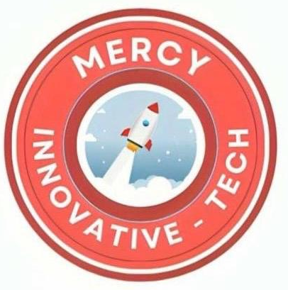
MI-TECH sarlu
Innovation, Passion, Excellence
P.O. Box 6998 Yaoundé, Cameroon
Tel : 696 767 009 / 681 191 547
Site : https://mi-tech.site
Email : contact@mi-tech.site

INTERNSHIP REPORT
CONCEPTION AND REALIZATION OF A SMART COMMUNITY PLATFORM FOR REAL-TIME INCIDENT REPORTING (SOS REPORT)

Internship carried from the 6th of July to 30th September 2026
In view of obtaining a Higher Technician Diploma (HTD) in Computer Sciences.
Option: Software Engineering –
Written By:
AKAMBA Walvede Daniel
Level II student at African Institute of Computer Science Cameroon

Supervised By:
Professional Supervisor
Mr. CHEBEU Sergio Junior
Full Stack Developer at MI-TECH
Academic Supervisor
Mr. BILL Nelson
Lecturer at AICS

Academic Year 2025 - 2026

DEDICATION

This work is dedicated to my grandmother Mme. KOUNOU Anastasie and to the entire AKAMBA family members for their numerous encouragement and support towards my academic success.

ACKNOWLEDGEMENTS

My gratitude goes to the following people who assisted in the realization of this project:

- The Resident Representative of AICS-Cameroon, Mr. Armand Claude ABANDA, for his words of encouragement and the different advices brought to us.
- To the honorable members of the jury who grant us their precious time to evaluate and judge our work.
- Our professional supervisor, Mr. Sergio Junior CHEBEU for the numerous advices, guidance and professional expertise shared with us.
- Our academic supervisor Mr. BILL Nelson for his support and help in the realization of the internship report.
- To our teachers for their numerous advices and guidance throughout the academic year.
- To the MI – Tech team for their numerous advices and guidance throughout the internship period.
- To my beloved parents Mr. & Mme. AKAMBA for their endless love, and moral support.
- To my beloved grandmother Mme. KOUNOU Anastasie for her endless love, moral and financial support.
- To my uncle and father Mr. Arthur ESSINDI for his trust, encouragement, advices and financial support.
- To my brother and my sisters for their love support and care regarding my studies.
- To our beloved friends, Mrs. AFANWI Kelly, KEIGOUM Ariane, DJOKO Joyce and all my classmates for their support and collaborative work throughout the academic year and for their numerous encouragements, love, and moral support.
- To each and every one not listed who participated in the realization of this project.

SUMMARY

LIST OF TABLES

LIST OF FIGURES

GLOSSARY

- 2TUP (Two Track Unified Process): A software development methodology that separates functional and technical requirements into parallel tracks, merging them during implementation.
- AICS (African Institute of Computer Sciences): A Cameroonian institution providing advanced training in computer science and technology
- API (Application Programming Interface): A set of rules and protocols that allows different software applications to communicate and exchange data with each other.
- DBMS (Database Management System): Software that manages and organizes data
- FCM (Firebase Cloud Messaging): A cross-platform messaging service by Google that enables developers to send push notifications and messages to user devices reliably
- IDE (Integrated Development Environment): Software tools (e.g., Visual Studio Code) for writing and testing code.
- LLM (Large Language Model): AI systems that process and generate human-like text. (e.g., Gemini Flash 3.5 )
- MERISE (Méthode d'Étude et de Réalisation Informatique pour des Systèmes d'Entreprise) An information system analysis and design methodology widely used in software engineering, particularly for database modeling through conceptual, logical, and physical data models.
- MI-TECH – Mercy Innovative Tech
- MVC (Model-View-Controller): A design pattern separating application logic (Model), user interface (View), and input handling (Controller).
- MVP (Minimum Viable Product): A basic version of a new product launched with just enough core features to satisfy early users and gather feedback for future development
- OTP (One-Time Password): A temporary, single-use numeric or alphanumeric code automatically generated to authenticate a user for a single login session or transaction.
- REST (Representational State Transfer): An architectural style for designing networked applications that relies on standard HTTP requests (e.g., GET, POST, PUT, DELETE) to access and manipulate data.
- SMS (Short Message Service): A standard text messaging protocol that allows cellular devices to send and receive short text messages over a mobile network.
- UI (User Interface): The visual layout, elements, and interactive points (screens, buttons, icons, forms) through which a human interacts with a digital device or software application.
- UML (Unified Modeling Language): A standardized visual language for modeling software engineering to specify, visualize, construct, and document the structure and behavior of software systems.
- UX (User Experience): The overall perception, emotion, and ease of use a person encounters when interacting with a product, service, or system.

ABSTRACT

In a context where public safety management faces delayed emergency responses, lack of real-time visibility, and reliability concerns, the study of the theme “CONCEPTION AND REALIZATION OF A SMART COMMUNITY PLATFORM FOR REAL-TIME INCIDENT REPORTING (SOS REPORT)”, undertaken at MI-TECH from the 6th of July to 30th of September 2026, aims at developing a real-time public safety platform to monitor urban security hazards, track emergency reports, and streamline threat verification for communities and local administration in Cameroon. The core objectives are to improve community safety, enable rapid incident reporting within seconds, and implement a 2-tier reporting system tailored to local connectivity and emergency challenges, by adopting a mobile crowdsourcing approach paired with community validation (Trust Score) and AI analytics. The platform leverages Flutter for the mobile client, Laravel for backend API management, and PostgreSQL for spatial data and real-time mapping. A key feature of the system is the integration of cloud-based Vision-LLMs (Google Gemini 3.5 Flash API) that processes media uploads in real time to automatically categorize incidents, detect false reports, and protect citizen privacy through automated face anonymization.
Keywords:
- Public Safety Platform
- Crowdsourced Incident Reporting
- Geofencing Notification Push
- Vision-LLM & Image Moderation
- Trust Score & Community Validation

RESUME

Dans un contexte où la gestion de la sécurité publique est confrontée au retard des interventions d'urgence, au manque de visibilité en temps réel et à des soucis de fiabilité, l'étude du thème « CONCEPTION ET RÉALISATION D'UNE PLATEFORME COMMUNAUTAIRE INTELLIGENTE DE SIGNALEMENT D'INCIDENTS EN TEMPS RÉEL (SOS REPORT) », menée chez MI-TECH du 6 juillet au 30 septembre 2026, vise à développer une plateforme de sécurité publique en temps réel afin de surveiller les risques sécuritaires urbains, suivre les signalements d'urgence et rationaliser la vérification des menaces pour les communautés et l'administration locale au Cameroun. Les objectifs principaux sont d'améliorer la sécurité communautaire, de permettre un signalement rapide des incidents en quelques secondes et de mettre en œuvre un système de signalement à 2 niveaux, adapté à la connectivité locale et aux défis des urgences, en adoptant une approche de crowd-sourcing mobile couplée à une validation communautaire (score de confiance) et à des analyses par IA. La plateforme s'appuie sur Flutter pour le client mobile, Laravel pour la gestion de l'API backend et PostgreSQL pour les données spatiales et la cartographie en temps réel. Une fonctionnalité clé du système est l'intégration des Vision-LLM basés sur le cloud (API Google Gemini 3.5 Flash) qui traitent les fichiers médias téléversés en temps réel pour catégoriser automatiquement les incidents, détecter les faux signalements et protéger la vie privée des citoyens grâce à l'anonymisation automatique des visages.

Mots-clés :
- Plateforme de Sécurité Publique,
- Signalement participatif d'Incidents (Crowdsourcing),
- Notifications push par Géofencing,
- Modèles Vision-LLM & Modération d'Images,
- Score de Confiance & Validation Communautaire,

GENERAL INTRODUCTION

In the digital era, public safety and municipal organizations are increasingly adopting technology to enhance community security and emergency response efficiency. However, in Cameroon, most urban communities and local authorities still rely on manual reporting, traditional phone calls, or unverified social media channels, leading to delayed interventions and severe security risks. To address these challenges, an internship was carried out at Mercy Innovative Tech a technology-focused company, from July 6th to September 30th, 2026, and a project was undertaken on the theme “CONCEPTION AND REALIZATION OF A SMART COMMUNITY PLATFORM FOR REAL-TIME INCIDENT REPORTING (SOS REPORT)”. The platform leverages Flutter for the mobile frontend, Laravel for backend REST API management, PostgreSQL for spatial incident storage, and Firebase FCM for geofenced push notifications (1–2 km radius). The platform aims to offer a scalable, accessible, and cost-effective solution to modernize public safety management in Cameroon and reduce emergency response times. This report is structured as follows:

- Insertion Phase: An introduction to the host company (Mercy Innovative Tech)
- Existing System: A review of current incident reporting practices and their limitations.
- Specification Book: An outline of user needs, project timeline, and functional requirements.
- Analysis Phase: A presentation of the system analysis methods and diagrams used.
- Conception Phase: A detailed description of the project’s design, and core components.
- Realization Phase: An overview of the solution implementation process.
- The Functionalities Testing Phase: An exploration of the application’s features, performance testing, and user benefits.
- User Guide: Instructions for installing the mobile application and navigating the administrative web dashboard.

PHAE

PHASE ONE: INSERTION PHASE

Preamble

This section of the report will cover details of how we were welcomed in the Host Company, presentation, organization and brief introduction to our project.
Content

INTRODUCTION

I.
WELCOME AND I
NSERTION

II.
GENERAL PRESENTATION OF THE COMPANY

III.
ORGANIZATION OF THE COMPANY

IV.
GEOGRAPHICAL LOCATION

V.
HARDWARE AND SOFTWARE RESOUYRCES

CONCLUSION

INTRODUCTION
The insertion phase within a company serves as a period for us to familiarize ourselves with the working environment, meet the staff, and connect with fellow interns. In this section, we will start by reflecting on our initial two weeks at the company, discussing the warm welcome we received and how we began to adapt to our internship setting. Next, we will dive into the company’s history, its mission, explore its main activities, and highlight some of its significant achievements. We will also gain an understanding of the company’s administrative and functional structure, which enables it to operate efficiently and achieve its objectives. Additionally, we will examine the hardware equipment utilized by the organization, as well as the software tools that support its daily operations. Finally, we will introduce the theme we selected for our internship period and provide a brief overview of it.

WELCOME AND INSERTION
WELCOME
I began my internship at Mercy Innovative Tech on July 6, 2026, at 9:00 a.m. Upon arrival, we were warmly welcomed by Mr. KENNE TILONG Aurel Gessy, the CEO of Mercy Innovative Tech, and his team. He briefly reintroduced the overview of the company’s current activities, ongoing projects, and the workflow of the internship.

INTERGRATION

Mr. Thierry WANGBARA and Mr. Sergio Junior CHEBEU organized a meeting during which they reminded us of the internal regulations of the establishment, its operation, its vision, its objectives, its services, its requirements and the development of the weekly schedule. Emphasis was placed on the conduct to be followed and compliance with the regulations. Several pieces of advice and recommendations were given to us during various sessions.

II. GENERAL PRESENTATION OF THE COMPANY

A. History and Mission
Mercy Innovative Tech (MI-TECH) is a Cameroonian company specializing in digital technologies and IT solutions. Its history originates from Mercy Innovation Lab, the IT branch of the charitable association Mercy for Cameroon, founded in 2023 by Dr. Thierry FOZING.
In its early days, Mercy Innovation Lab's mission was to put digital technologies at the service of social development and to improve the living conditions of Cameroon's most vulnerable populations. With this in mind, the organization developed digital solutions aimed particularly at facilitating access to essential services such as healthcare and education, while also helping strengthen the digital skills of young people and communities.
Under the leadership of Mr. KENNE TILONG Aurel Gessy, General Manager, Mercy Innovation Lab progressively built expertise across several technological fields, including web and mobile application development, computer networks, and digital skills training. Its operations relied on a multidisciplinary team made up of engineers, developers, designers, and network specialists. This diversity of skills allowed it to design and implement solutions tailored to the realities and needs of the Cameroonian context.
As the organization evolved, it strengthened its technical capabilities and experience in designing digital solutions. This evolution led to an organizational and strategic transformation with the creation of Mercy Innovative Tech (MI-TECH), which succeeds Mercy Innovation Lab.
Unlike Mercy Innovation Lab, which was the IT branch of the charitable association Mercy for Cameroon, MI-TECH is now a fully independent, for-profit company. This new direction allows the company to grow its commercial activities, offer its services to various types of clients, and pursue technology projects that meet the needs of businesses, organizations, and individuals.

Today, Mercy Innovative Tech is thus part of a dynamic of technological development and innovation in Cameroon. The company is active in the design and development of web and mobile solutions, IT services, computer networks and infrastructure, as well as digital technology training.
The transformation of Mercy Innovation Lab into Mercy Innovative Tech therefore marks a new stage in the organization's evolution. While retaining the experience, skills, and technological vision acquired since its founding in 2023, MI-TECH now adopts an organizational structure and business model suited to a private company, with the ambition of contributing lastingly to the digital transformation of organizations and the development of the technology sector in Cameroon.

B. Aims
The goal of Mercy Innovative Tech is to develop innovative solutions that meet the specific needs of African populations. We believe that technological knowledge knows no borders and that developing local expertise can have a positive impact globally.

C. Values
- Innovation: We encourage creativity and the search for new approaches to solve the challenges faced by Africans.
- Local impact, Global Reach: Our solutions aim to tangibly improve daily life while potentially influencing the rest of the world.
- Skills Development: We focus on training and nurturing African talent to build sustainable expertise.
- Collaboration: We work hand in hand with our partners and local communities to co-create relevant solutions.

D. Activities
- Modular, fully equipped workspaces.
- Personalized support from experienced mentors.
- Training and workshops on key topics for startups.
- Administrative and logistical support to ease project launches.
- Mobile and web development services.
- Network services.
- Graphic design and digital marketing.
- AI integration and Cybersecurity implementation solutions

E. Ongoing Projects
Table 1: Team Project Table
Projects | Description
MANAGE-GLY: | A mobile application aimed at dietary management.
Pharma Care: | A complete management solution for pharmacies
Med Report: | An Intuitive mobile application for Health Professionals to assist and manage patients;
School Manager: | A complete solution for scholar management; managing students, teachers, notes, transcripts, payments and timetable on one dashboard.
Save Me: | A personal security app to keep you protected anytime, anywhere

F. Team
Table 2: Team Members and Roles
Members | Role
Mr. KENNE TILONG Aurel Gessy | Chief. Technical Officer
Mr. WAMGBARA Thierry | Head of Network Services.
Mr. CHEBEU Sergio Junior, | Full Stack Developer.
Mr. NWABO Franck Barthel, | web developer.
Mr. MABONG ANABA Rosnel Pacely, | assistant developer.
Mr. NOUPA Steve, | assistant developer.

III. ORGANIZATION OF THE COMPANY
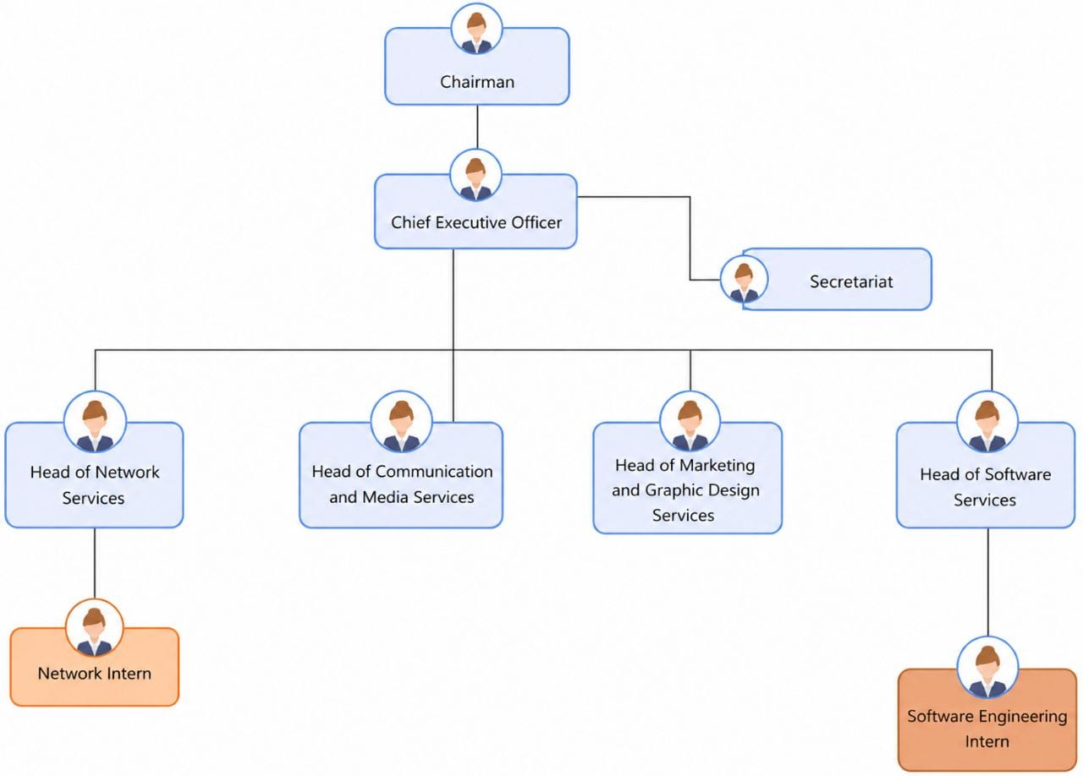
Figure 1: Mercy Innovative Tech Organizational Chart

IV. GEOGRAPHICAL LOCATION

Figure 2: Mercy Innovative Tech Geographical Location (Source : EdrawMax)

V. HARDWARE AND SOFTWARE RESOURCES
The effective operation of Mercy Innovative Tech relies on a combination of hardware and software resources that support software development, training, communication, and administrative activities. These resources provide the technical infrastructure required for the design, implementation, testing, and deployment of digital solutions. The following tables present the main hardware and software resources available within the company during the internship period.

HARDWARE RESOURCES

Table 3: Hardware Resource
EQUIPMENT | Quantity | Purpose
NEC Projector | 2 | Used for presentations and training sessions
Solar Equipment | 1 | Ensure service continuity during power outages
Samsung Printer | 1 | Printing documents
MacBook Pro(2017) | 1 | Development workstation
MSI Gaming Laptop | 1 | Development Workstation
IIYAMA Monitor | 1 | Display Workstation
Modems (2 Flybox, 1 Camtel Fiber) | 3 | Internet connectivity
Synology Server | 1 | Files Storage and database management
Network Switch | 1 | Connects network devices
Router | 1 | Network routing and internet access
Canon EOS 700D Camera | 1 | Media capture
IR Night Vision Camcorder | 1 | Video recording
Samsung Laptops | 2 | Development workstations
HP Laptops | 3 | Development workstations
Acer Laptop | 1 | Development workstation
Toshiba Laptop | 1 | Development workstation
Lenovo Laptop | 1 | Development workstation

SOFTWARE RESOURCES

Table 4: Software Resources
SOFTWARE | TYPE | PURPOSE
Windows 11 Pro | Operating System | Development environment
Ubuntu 21/22/23 | Operating System | Software development and server management
Google Cloud Storage (300 GB) | Cloud Storage | File and data storage

VI. BRIEF PRESENTATION OF THE PROJECT THEME
Upon starting my internship at Mercy Innovative Tech, I was encouraged to work on a project that would not only be technically challenging but also have a tangible impact on society. In line with Mercy Innovative Tech’s vision of contributing to sustainable development through innovative digital solutions, I identified an opportunity to design a system that addresses key operational and safety challenges faced by urban communities and public safety stakeholders in Cameroon. The proposed theme: “CONCEPTION AND REALIZATION OF A SMART COMMUNITY PLATFORM FOR REAL-TIME INCIDENT REPORTING (SOS REPORT).”, aims to create a real-time public safety platform capable of monitoring urban security hazards, tracking emergency reports, and automating threat verification. This solution is designed to improve community safety, streamline incident verification, and provide rapid, anonymous reporting tailored to local connectivity and emergency challenges through a minimal-friction architecture. The system consists of several integrated components:
- A Mobile Application (Flutter): Running on citizens' smartphones to capture location-based incident data, support express sub-second reporting via categorized and neutral interfaces, and display real-time safety maps and geofenced alerts (1–2 km radius).
- A Multimodal AI Engine (Google Gemini 3.5 Flash API): Integrated into the backend to automatically categorize reported threats, evaluate media-to-category consistency, detect false reports, and protect citizen privacy through automated facial and license plate anonymization.
- A Central Administrative Web Dashboard (Laravel + Livewire 3 + Tailwind CSS): For system administrators and local community leaders to monitor live incident heatmaps, review contested reports, manage user Trust Scores, and coordinate local safety responses.
. By combining instant cloud AI verification with community-based confirmations (upvotes/downvotes from nearby users) and dynamic phone-number-based Trust Scores, the system accurately filters out spam and false alerts without requiring complex user registration or compromising reporter anonymity.

CONCLUSION
The insertion phase at Mercy Innovative Tech provided a valuable foundation for this work. This initial experience allowed me to quickly adapt to the professional environment and company culture. During this phase, I gained a deeper understanding of Mercy Innovative Tech’s mission, particularly its focus on innovative and scalable software solutions and the development of highly skilled software engineering and network administration professionals. The welcoming atmosphere fostered collaboration, open communication, and knowledge sharing between the staff and interns. This environment reinforced my motivation to contribute effectively to the company’s goals. Following this brief but insightful phase, I selected the project theme: “CONCEPTION AND REALIZATION OF A SMART COMMUNITY PLATFORM FOR REAL-TIME INCIDENT REPORTING (SOS REPORT).” This theme aligns with Mercy Innovative Tech’s commitment to delivering impactful technology that addresses critical societal needs in public safety and emergency management. Having established a clear project direction, I am now prepared to proceed to the study of existing systems to identify gaps and opportunities for improvement.

PHAE

PHASE ONE: INSERTION PHASE

PHASE TWO: TECHNICAL PHASE

Preamble

The technical phase is a document that describes the process, progress, or results of a scientific research. It also includes a detailed analysis and the conclusions drawn from that research.
Content

VI.

FILE 7: USER GUIDE
FILE 1: THE EXISTING SYSTEM
FILE 2: THE SPECIFICATION BOOK
FILE 3: THE ANALYSIS PHASE
FILE 4: CONCEPTION PHASE
FILE 5: REALIZATION PHASE
FILE 6: TEST OF FUNCTIONALITIES

FILE 1:

THE EXISTING SYSTEM

Preamble

The existing system is a file that provides a view of how the current system of study works, that is, outlined how the different activities are carried out, and also provides a deep understanding of this system and the limitations it faces, the problem resulting from these and the solution we propose.
Content

INTRODUCTION

I.
PRESENTATION OF THE PROJECT THEME

II.
DESCRIPTION OF THE EXISTING SYSTEM

III.
CRITICISMS OF THE EXISTING SYSTEM

IV.
PROBLEMATIC

V.
PROPOSED SOLUTION

CONCLUSION

INTRODUCTION
As Software Engineers, our role is to solve societal problems by bringing digital solutions that will hinder life easier for everyone. To develop these effective solutions, we must first ask ourselves critical questions that will help us to understand why the problem exists and how it is currently being addressed, these are the key points the existing system analysis aims at targeting for us to ensure the proposal of solutions that will improve or replace the current system for a better one.

PRESENTATION OF THE PROJECT THEME
Our project theme is “CONCEPTION AND REALIZATION OF A SMART COMMUNITY PLATFORM FOR REAL-TIME INCIDENT REPORTING (SOS REPORT)”. The mobile application aims to provide citizens and emergency services with a centralized, AI-driven platform to report, moderate, and track local incidents rapidly. In the current landscape of urban security, traditional emergency response mechanisms face challenges related to communication latency, inaccurate incident descriptions, and false emergency report (pranks). SOS Report addresses these challenges by offering a scalable solution that utilizes spatial databases and artificial intelligence to send alerts with proofs to the adequate emergency services.

DESCRIPTION OF THE EXISTING SYSTEM
Case study: The Fire Station of Mimboman and the 16th District Police Station at Mimboman Chateau neighborhood

Fire Station Current System
At the Fire Station of Mimboman, incidents are reported either by going at their station and verbally describing it or by calling the official phone number “118” and describing the situation. Once they receive the call and description of the incident, they listen to the background sound (or voices) and wait for any 2 or more reporting of that same incident, before they go on the field for intervention.

The 16th District Police Station Current System
At the 16th District Police Station, incidents are reported either by going at their station and verbally describing it or by calling the official phone number “117” or their private phone number, and describing the situation. Once they receive the call and description of the incident, they go directly on the field for intervention.
The current emergency reporting system in many urban areas in Cameroon relies heavily on classical phone calls to centralized dispatch centers.
- Citizens witnessing or experiencing a danger must manually dial emergency numbers and verbally describe the situation, verify their identity, and explain their location.
- Operators must manually log the details, attempt to verify the authenticity of the call, and dispatch the appropriate units.
- Communication between witnesses and responders is strictly linear and lacks visual or spatial context.
There are also other systems that help in the reporting of incidents; we can find
- SOS Cameroon: a unique safety app that uses SMS t bridge communication and safety across multiple devices. It enables critical emergency alerts and location sharing, regardless of the internet connectivity its functionalities are the following:
- Alert transmission to your predefined contacts in case of an emergency
- Tracking of the current devices, if the phone has been stolen or lost.
- Safety checking features, allowing remote monitoring and localization of nearby hospitals or services stations in case of danger;
- Customized features such as shaking phone, voice note or clicking on a large SOS button to alert loved ones in case of danger.
Target users: any Cameroonian

- Dakar Safe: a community platform for reporting security incidents in Dakar. It allows citizens to report, view and react to security incidents in their neighborhood. Its functionalities include:
- Alerts transmission when the user enters a high-risk area or when incidents are reported in their neighborhood.
- Community moderation system for votes confirmation or false incidents
- Report form for incidents
- SOS report button for emergency incidents
- Personal medical information push to emergency services in case of an SOS alert (with the users concerns)
Target users: citizens of Dakar in the Senegal country.

CRITICISMS OF THE EXISTING SYSTEM
The manual and voice-based emergency reporting system presents significant limitations that hinder rapid intervention:
Table 5: Criticism Table
LIMITATIONS | CONSEQUENCE | PROPOSED SOLUTION
Most of the actual software systems mostly focus on self-emergency reporting | The public services still rely on traditional incident reporting methods for other kind of emergency, and obviously are still highly vulnerable to wastage of time and resources when encountering false reporting. | A system that permits a global possibility of reporting incidents based on the category of problem encountered
Lack of Visual Evidence: | Low trust or risk of doubt on the incident reported | Reporting system based on uploading of photo, short videos for visual proof.
Vulnerability to False reporting (pranks): | Services such as firefighters and police take more time for reactivity. | A system of Trust score per citizen, enhancing the effectiveness of reactivity when the score of the reporter is high
Inaccurate Geolocation from callers in distress often struggling to provide precise addresses | More time spend in analysis to locate the exact incident location. | GPS coordinates are sent alongside the report, hindering the localization easier
More time taken to search and catch prankers after an intervention on a false reporting. | Many prankers still escape the services vigilance and time wasted to track them indirectly | The system automatically keeps Track of every device sending a report

PROBLEMATIC
In high-stress emergency situations, efficient report of the problem and immediate decision taken by public services are vital for citizen survival. However, the current verbal and phone call systems increase administrative workload and slows down the effective intervention the requested services. Given these critical flaws, the fundamental question arises: HOW CAN WE HELP THE PUBLIC SERVICES TO PERFORM A MORE RAPID INTERVENTION WHEN AN INCIDENT IS REPORTED?

PROPOSED SOLUTION
To overcome the inefficiencies of the current system, we propose the development of SOS Report; a comprehensive mobile community platform designed to modernize incident reporting.
- For the Citizen: A cross-platform Flutter application that authenticates with 6-digit Twilio OTPs, features a single-tap SOS trigger recording 5s of ambient audio, automatically captures satellite coordinates, and transparently falls back to background GSM SMS if offline.
- For the Emergency Services (Police, Fire, Medical): Role-specific Livewire web dashboards displaying real-time incident queues, AI trust evaluations, clickable maps, and dedicated "Mark as RESOLVED" and "Mark as FALSE ALERT" toggle buttons that dynamically adjust citizen trust scores.
- For the Central System Administrator: An overarching command center with system configuration, user auditing, override validation buttons, and exclusive interactive controls to unblur and reblur citizen faces on evidence media.

CONCLUSION
The study of the existing system is a crucial step in the development of a digital solution. Taking the time to observe and understand the actual flow of a particular system, the output result, the weaknesses, challenges of this one, permits the developer have a proper foundation for the conception and realization of a new and better system, which is exactly at what aims the file of the existing system.

FILE 2:

THE SPECIFICATION BOOK

Preamble

The Specification Book is a document created between the client and the developer to define what the product must do and how it should behave. It guides the development process by outlining all the required features, goals, and constraints. For this project, it serves as a reference for building an AI voice agent platform for interview preparation. Its purpose is to ensure that the final product meets user needs and follows clear, agreed-upon expectations throughout the development phase.
Content

INTRODUCTION

I.
CONTEXT AND JUSTIFICATION OF THE PROJECT

II.
OBJECTIVES OF THE PROJECT

III.
EXPRESSION OF NEEDS

IV.
PROJECT PLANNING

V.
ESTIMATED COST OF THE PROJECT

CONCLUSION
VI.
VII.
PROJECT CONSTRAINTS

DELIVERABLES

INTRODUCTION
The specification document for our report serves to clarify our theme, enhancing our understanding and increasing the chances of its success. To define the project's scope, we will outline the context of our theme. From this context, we will identify the specific problems we aim to address throughout the project. After presenting our proposed solution, we will discuss the objectives we have established for the project. We will also examine the needs our system will fulfill, considering both functional and non-functional aspects. Next, we will assess the estimated financial resources required for our project and outline a timeline to ensure we complete it on schedule. Finally, we will address the expectations for our project deliverables by the end of the project.

CONTEXT AND JUSTIFICATION OF THE PROJECT

Context
In a context where urban insecurity is rising, citizens are frequently exposed to dangerous situations where traditional means of seeking help are insufficient. The lack of an integrated digital platform results in delayed responses and an uninformed public. We can have the following results of researches undertaken on these situations:
"Road traffic crash mortality in Southwest Cameroon: a multicenter hospital study." Published in 2025/2026 (PubMed record PMID: 42318574; PMC ID: PMC13272510; the PMC and PubMed by Otang Thierry Otang, Nana Theophil Chunteng, Brandon Carl Monika Pouekoua, Leslie Tasha Mbapah, Ernest Kikah Ndifor, Ngomba Divine Martin Mokake, Alain Chichom Mefire) . What the abstract states: “a five-year retrospective study (Jan 2020–Dec 2024) across three regional referral hospitals in Southwest Cameroon, 3,266 RTC admissions (“Results” paragraph 3 line 1)., 153 in-hospital deaths (4.7% mortality); on multivariable analysis, delayed presentation of 30–60 minutes was independently associated with a doubling of mortality risk (“Results” paragraph 3 line 4)”.
“Cameroun : Incendie meurtrier à Yaoundé - Une mère et ses cinq enfants périssent à Etoa Meki” AllAfrica (republishing Cameroonian press), dated 20 February 2026. Located in the section titled “Une tragédie qui interroge sur les délais d'intervention”, states firefighters arrived only after the house was already fully destroyed.

Justification
The implementation of a mobile application like SOS Report is justified by the urgent need to reduce reaction time of these Emergency services when an incident is reported, thus, reducing the rate of mortality during domestic fire catch, road incident and any other incident involving human life. By leveraging modern technologies such as Flutter for cross-platform accessibility and AI for instant validation, this system will empower citizens, reassure users through real-time community monitoring, and optimize the deployment of emergency services.

II. OBJECTIVES OF THE PROJECT

General Objective
The conception, realization and deployment of an end-to-end digital emergency reporting system that will link both citizens via a quick access platform (mobile app) to public emergency services via a proper monitoring interface (web platform), and will guarantee instant, geolocated alert delivery across both online cloud and offline GSM cellular networks in Cameroon.

Specific Objectives
- Develop a Flutter mobile app capable of locking satellite coordinates and capturing 5 seconds of ambient audio upon SOS trigger.
- Implement a 6-digit SMS OTP authentication workflow using Twilio's API, tailored for Cameroon MTN and Orange numbers (+237),
- Architect a resilient dual-mode dispatch logic: attempting high-speed cloud upload with a 3-second timeout, falling back automatically to direct background GSM SMS.
- Integrate Google Gemini 3.5 Flash to parse emergency media, resolve Cameroonian neighborhoods, compute an AI credibility score (0–100%), and detect screen recaptures.
- Synthesize automated bilingual voice phone calls and instant SMS dispatches via Twilio.
- Implement automated AI face detection and frosted-glass privacy blurring on photos and videos, granting exclusive unblur/reblur rights to the System Administrator.
- Architect a dynamic public emergency service registration system with an unconstrained Admin Service Naming Engine for custom agency creation.
- Build specialized web dashboards for Police, Fire, Medical, and Administrative authorities with Livewire 3 and PostGIS GiST spatial indexing.

III. EXPRESSION OF NEEDS

Functional Needs
These are the requirements that a system must meet to fulfill its purpose, that is, what the SOSReport system should accomplish. The main modules and functionalities include:

Table 6: Functional Needs
Actor | What They Must Be Able to Do in The System
Visitor | - Create an Account
Citizen | - Authenticate  - Report Incident via SOS button  - Report Incident via Standard carousel buttons  - Receive local danger alerts  - Consult heat map  - Consult Incident Details  - Contest nearby incident  - Confirm nearby incident  - Manage their profile
Emergency Services | - Authenticate  - Register an Account  - Consult blurry photo  - Consult blurry video  - Listen to audio  - Consult Trust Score  - Consult GPS coordinates  - Mark incident as Resolved  - Mark incident as False Alert  - Receive local danger alerts  - Consult heat map  - Manage their profile
System Administrator | - Authenticate  - Consult blurry photo  - Consult blurry video  - Listen to audio  - Consult Trust Score  - Consult GPS coordinates  - Unblur faces  - Override to Mark incident as Validated  - Override to Mark incident as False_Alert  - Receive local danger alerts  - Consult heat map  - Manage their profile  - Delete user account  - Suspend user account  - Ban user account  - Consult user account  - Consult system analytics

Non-Functional Needs
It specifies the quality attributes of a software system. They judge the software system application based on the system’s requirements, performance, usability, scalability, portability and other non- functional standards that are critical to its success. Failing to meet the non-functional needs can result in the system not fulfilling the user’s needs.
- High Performance and Low Latency: Gemini API analysis and response time should be very low, and the system must handle offline failover when no internet available.
- Fault Tolerance and Offline Resilience: The mobile app must not crash on network timeouts, null coordinates, or microphone permission denials.
- Data Security: The system should perform protection of sensitive information from unauthorized access
- Scalability: The system should be capable of handling over 1,000 concurrent mobile connections and processing 500 reports/hour.
- Emergency effectiveness: The SOS alert transmission process must execute in under 8 seconds (inclusive of a 3-second safety delay and 5-second environmental capture).
- Usability: The system should have an intuitive and user-friendly interface, and passive legal deterrence message must be permanently visible on the reporting UI to prevent abuse.
- Availability: The application must cache data locally if the internet connection drops, retrying the upload automatically upon reconnection.
- Security and Law: Device IDs and phone numbers must be securely logged to allow administrators to track and ban malicious users.

IV. PROJECT PLANNING
We began our internship on the 6th of July, till the 30th of September 2026. Management of work time was a key habit so as to finish the project within the given period. This section presents how the work phases were scheduled throughout the internship period.

A. Chronogram of Activities
Table 7: Chronogram of activities
Phase | Task Description | Duration | Period
INSERTION | Enterprise Insertion Phase | 14 days | 6th July – 19th July 2026
EXISTING SYSTEM | Existing System Study with Field Survey | 5 days | 20th July – 24th July 2026
SPECIFICATION BOOK | Specification Book Treatment | 11 days | 25th July – 4th August 2026
ANALYSIS | Analysis of the solution and drafting of the analysis document | 20 days | 5th August – 24th August 2026
CONCEPTION | Drafting of the Conception Book | 10 days | 25th August – 3rd Sept 2026
REALIZATION | Realization Phase | 18 days | 4th Sept – 21st Sept 2026
TEST OF FUNCTIONALITIES | Testing of the software and debugging | 5 days | 22nd Sept – 26th Sept 2026
INSTALLATION AND USER GUIDE | User Guide & Final Report drafting | 4 days | 27th Sept – 30th Sept 2026

B. Gantt Project planning

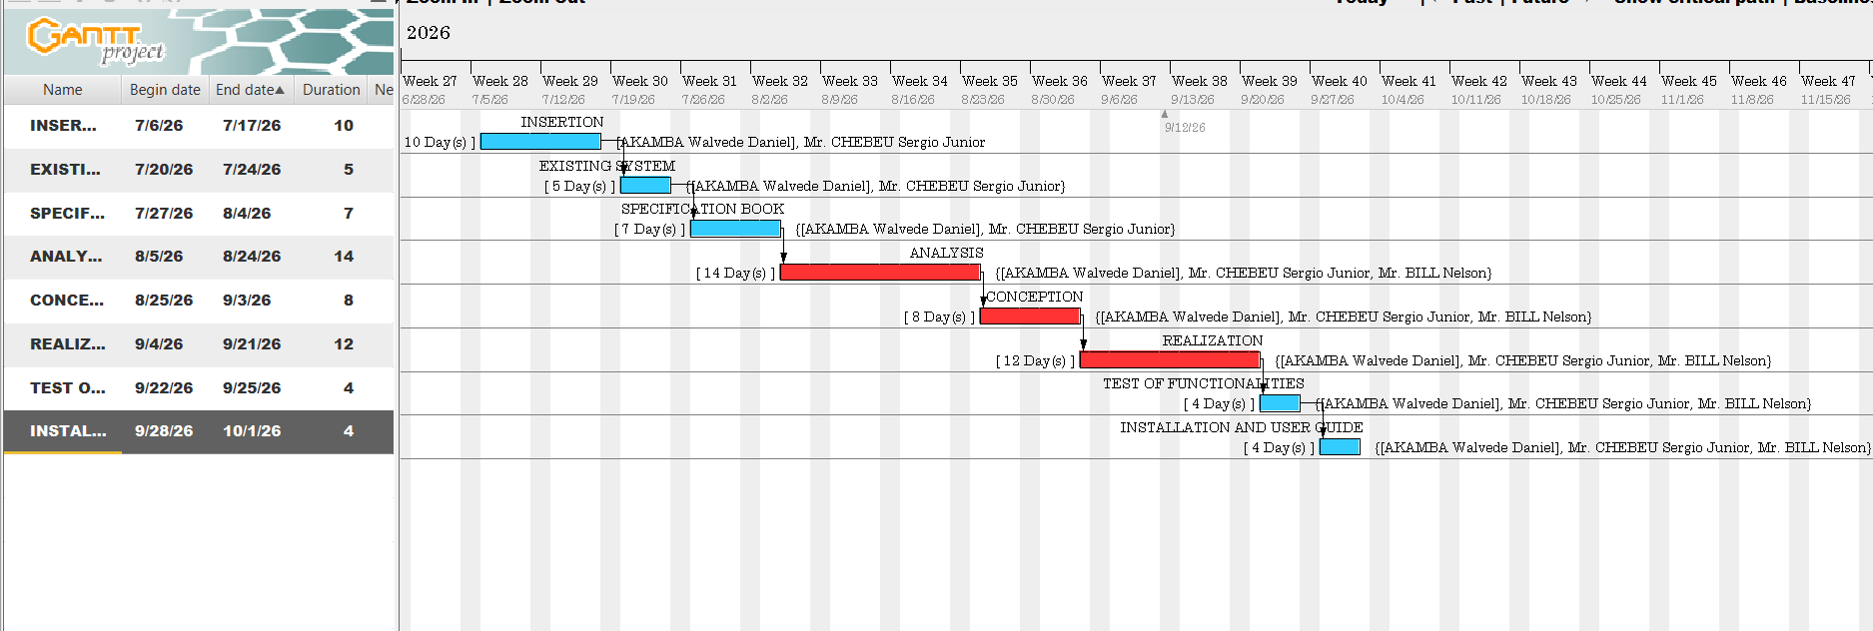
Figure 3: Gantt Project Planning

V. ESTIMATED COST OF THE PROJECT

A. Software Resources
For the realization of this project, we will need the following software applications:
Table 8: Software Resources (source: https://www.microsoft.com/en-us/d/windows-11-pro/dg7gmgf0d8h4)
Software Designation | Description | Quantity | Subtotal (FCFA)
Windows 11 Pro License | Operating System Environment | 1 | 120,000
Visual Studio Code | Code development tool | 1 | Freemium
Visual Paradigm Academic | System Modeling Tool | 1 | Freemium
Microsoft office 365 | productivity suite, useful for editing; documents, spreadsheets, presentations and emails | 1 | 47,998
Twilio Telephony Trial | Voice Call & SMS Dispatch API | 1 | 10,000
Google Gemini API Tokens | Multi-modal Vision & Spatial Triage | 1 | 25,000
TOTAL SOFTWARE RESOURCES |  |  | 202,998 FCFA

B. Hardware Resources
Table 9: Hardware Resources
Hardware Designation | Technical Specifications | Quantity | Unit Cost (FCFA) | Subtotal (FCFA)
Development Workstation | Core i7, 32GB RAM, 1TB SSD | 1 | 450,000 | 450,000
SIM Cellular Test Cards | MTN Cameroon and Orange Cameroon 4G SIMs | 1 | 1,000 | 1,000
Cellular Internet Subscriptions | Orange 20GB High-Speed Bundles | 3 months | 19,000 | 57,000
AWS Server | t3.micro/t4g.micro, 1 Go RAM | 3 months | 6,000 | 18,000
TOTAL HARDWARE RESOURCES |  |  |  | 526,000 FCFA

C. Human Resources
Table 10: Human Resources
Professional Role | Daily Rate (FCFA) | Duration | Subtotal (FCFA)
Project Manager | 65,000 | 30 days | 1,950,000
Backend Developer | 55,000 | 28 days | 1,540,000
Mobile Flutter Developer | 50,000 | 28 days | 1,400,000
Analyst | 100,000 | 20 days | 2,000,000
Tester | 50,000 | 5 days | 250,000
TOTAL HUMAN RESOURCES |  |  | 7,140,000 FCFA

Global Project Budget Summary
Table 11: Estimation cost of project
Cost Category | Amount in FCFA
Total Software Resources | 202,998 FCFA
Total Hardware Resources | 526,000 FCFA
Total Human Resources | 7,140,000 FCFA
Subtotal Direct Costs | 7,868,998 FCFA
Unexpected charges (10%) {(Total cost) * 10%} | 786,899.8 FCFA
OVERALL ESTIMATED BUDGET | 8,655,897.8 FCFA

List Of Participants
The table below presence the different persons who took part in the accomplishment of this project. They include:
Table 12: List of participants
Names | Function | Role
Mr. CHEBEU Sergio Junior | Follows up interns at the Company level | Professional Supervisor
Mr. BILL Nelson | Follows up student at the Academic level | Professional Supervisor
Mr. AKAMBA Walvede Daniel | Second year student at AICS-Cameroon | Project head, analyst, conception and coding of project, testing

VI. PROJECT CONSTRAINTS
To put in place this application, we must respect three main constraints which includes:
- Time: The MVP must be developed, tested, and deployed within the strict timeframe dictated by the academic defense schedule.
- Technical: Hardware-level triggers (eg, volume buttons) are restricted by mobile OS sandboxing; thus, all panic triggers must be software-based UI elements
- Legal: The application must comply with local laws regarding false emergency reporting, enforced via mandatory UI disclaimers.
- Time Constraint: the complete design, implementation, and realization of this system must respect the dateline attributed to it (3 months) including respecting the fixed objectives of the project.
- Budget Constraint: The completion of this project will involve costs related to human resources, software licenses, hosting services, and development materials. the fixed budget for the realization of this project must be strictly respected.

VII. DELIVERABLES
In project management, a deliverable is any tangible outcome resulting from the completion of a service or task. For the SOSReport project, the key deliverables are:
- The fully functional SOS Report Application (APK for Android).
- The Application Source Code (Frontend and Backend).
- The comprehensive Academic Report
- The User Guide and Installation Manual.
- The PowerPoint Presentation for the academic jury.

CONCLUSION
In conclusion, the specification book has permitted us to present the general and specific objectives of SOSReport, its constraints, its functional and nonfunctional needs, lay out the different resources needed for its realization, and finally the project planning. The end of this document will enable us to now move forward to the Analysis Phase, where we will model the system using appropriate modeling languages and methodologies, to create detailed system designs and conduct a comparative study of these approaches. This analysis will guide the development and ensure that the system meets all outlined requirements effectively.

FILE 3:

THE ANALYSIS PHASE

Preamble

The main objective of the analysis file is to capture the user’s need, by detailly breaking down the field of study and to have a clear understanding of the system with the help of diagrams. To achieve this, we will need to choose the best method of analysis to apply for our system.
Content

INTRODUCTION
I.
METHODOLOGY

A. COMPARATIVE STUDY OF UML AND MERISE.

B. COMPARATIVE STUDY OF UNIFIED PROCESSE

II.
MODELLING OF THE PROPOSED SOLUTION

A. USE CASE DIAGRAM

CONCLUSION
B. COMUNICATION DIAGRAM

C. SEQUENCE DIAGRAM

D. ACTIVITY DIAGRAM

INTRODUCTION
The realization of a good project is mainly based on its analysis. A poorly analyzed project cannot yield good results. Analysis is the decomposition of a problem into its various elements for computer processing. The main objective of this file is to capture the user's needs, delimit the field of study, and gain a clear understanding of the system being studied. In this section, we will justify our choice of methodology and proceed to modeling the functional requirements of the SOS Report platform.

I. METHODOLOGY
Analysis is the fundamental step in the design of software. It forms the base for the realization of every information system. Several methods and languages have been put in place to facilitate the analysis and design of information systems, mainly MERISE and UML.

A. Comparative Study of UML and MERISE
MERISE and UML both help design information systems, but they differ mainly in what they are and how they represent a system: MERISE is a full analysis-and-design methodology, while UML is a standardized visual modeling language

- MERISE (Méthode d’Étude et de Réalisation Informatique pour les Systèmes d’Entreprise)
It is a structured methodology for analyzing, designing, and implementing information systems, especially databases and business applications. It proposes to consider the real system from two separate points of view:
The Static View (data) which is modeled through three abstraction levels:
- Conceptual Data Model (CDM); what data exists and how it relates (entity–relationship style)
- Logical Data Model (LDM); more detailed, closer to relational structures
- Physical Data Model (PDM); actual database tables, keys, indexes, etc.

And the Dynamic View (treatments). Which is modeled through parallel levels:
- Conceptual Treatment Model (CTM); high-level business processes
- Organizational Treatment Model (OTM); who does what, where, with which resources
- Operational/Physical Treatment Model; concrete workflows, screens, batch jobs, etc.

- UML (Unified Modeling Language):
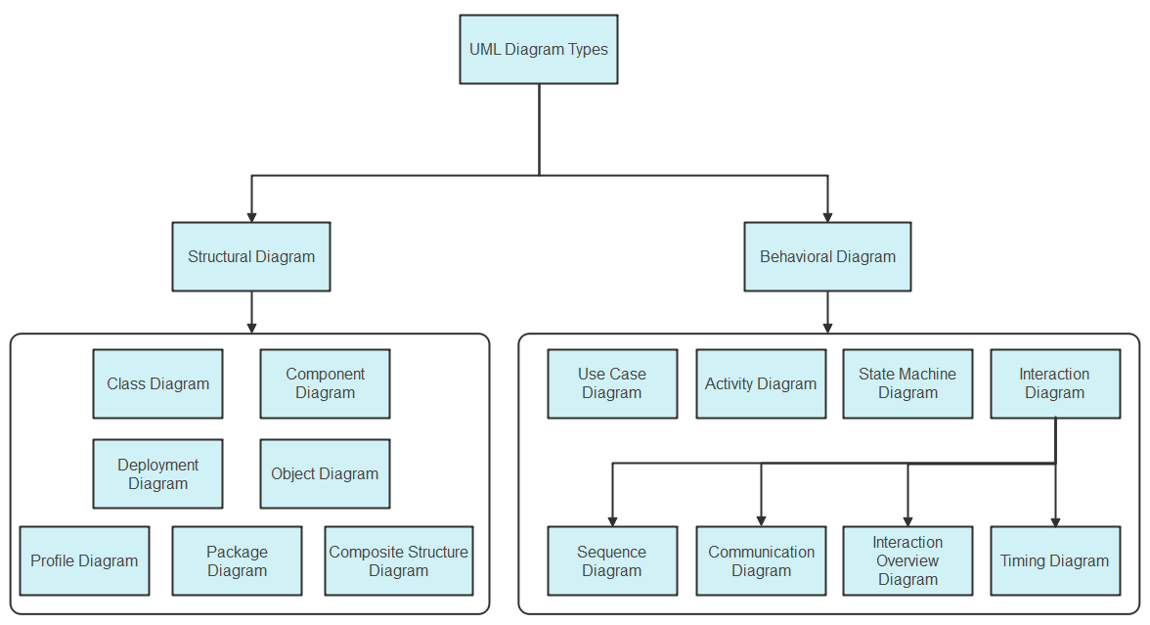
UML is a standard notation for the modeling of real-world objects as a first step in developing an object-oriented design methodology. Unlike MERISE, UML combines data and processing, centralizing the data of a type and the associated processing to limit maintenance points in the code.
Figure 4:UML diagrams (source:https://images.edrawsoft.com/articles/what-is-uml/uml-diagram-types.png)

Table 13: Comparison between MERISE and UML
Point of Comparison | MERISE | UML
Definition | Method of analysis and design for information systems. | Visual modeling language for object-oriented systems.
Approach | Separate data and treatments (procedural approach). | Combines data and processing (object-oriented approach).
Standardization | Mainly used in French-speaking environments. | Internationally recognized standard.
Data and behavior | Separates data models from treatment/process models | Usually, groups data and behavior around objects/classes; a class can define attributes and operations
Modeling progression | Uses abstraction levels such as conceptual, logical, and physical models | Uses different diagrams for distinct views, such as class, use-case, activity, sequence, component, and deployment diagrams
Process modeling | Models’ processes/treatments separately, including conceptual and organizational views | Represents behavior through activity, sequence, state-machine, and use-case diagrams

B. Comparative Study of Unified Processes
Since UML is a modeling language and not a method, it must be associated with a Unified Process (UP) to provide a development framework. 2TUP, short for Two-Track Unified Process, is a software-development process that uses UML; it is not a part or “version” of UML itself. UML supplies the modeling diagrams, while 2TUP supplies the workflow for applying them during a project. 2TUP organizes development around two parallel concerns:
- Functional track: determines what the system must do for users and the business.
- Technical/architecture track: determines how the system will be built: technology choices, architecture, performance, security, deployment, and reusable technical components.
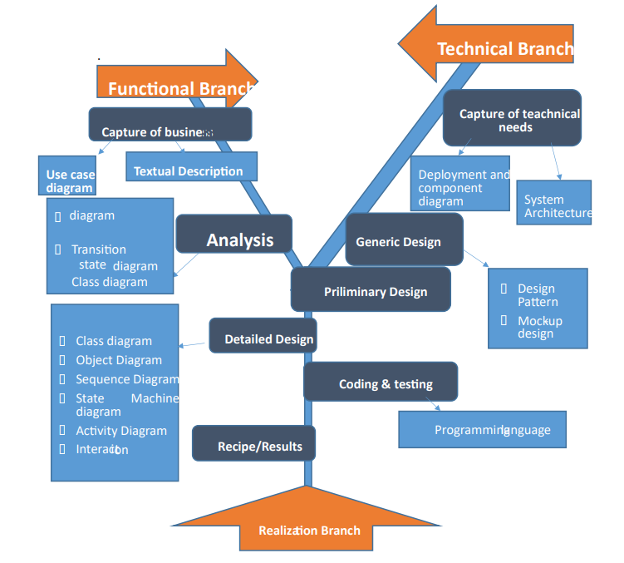
Figure 5: 2TUP diagram (Source: Miss. NYANGONO NDO EMMANUELLA DORETTE EMIE’S Report (session 2024))

Those two tracks later join in a realization phase, producing the familiar Y-shaped development cycle. The separation is intended to handle business changes and technical changes independently until they need to be integrated.

Table 14: Understanding 2TUP branches
Branch | Main question | Typical UML artifacts
Functional branch | “What business services and user outcomes are required?” | Use-case diagrams, activity diagrams, domain/class models, system sequence diagrams
Technical branch | “What architecture and technical services are needed?” | Component diagrams, deployment diagrams, package diagrams, technical class/interface models
Realization branch | “How do we integrate, implement, test, and deliver it?” | Detailed class and sequence diagrams, component designs, test models

Choice of the Analysis Method
The choice should be guided based on the following criteria:
MERISE, when your emphasis is on rigorous business analysis, organizational workflows, and relational database design, particularly in environments already using MERISE conventions; and UML, when you are building object-oriented software and need to communicate software structure, runtime interactions, components, and deployment.
For the SOS Report project, our choice is based on the modeling language UML associated with the 2TUP process due to the following criteria:
- UML is based on the object-oriented approach, which perfectly aligns with our chosen technologies (Flutter and Laravel).
- 2TUP allows for flexibility in project analysis and is highly user-oriented, ensuring the software responds directly to citizen and emergency service needs.
- 2TUP's separation of functional and technical tracks allows us to manage the complexity of integrating spatial databases (PostGIS) and AI APIs (Gemini) without losing focus on the core user experience.

II. MODELING OF THE PROPOSED SOLUTION

A. Use Case Diagram
1. Definition
The use case diagram shows the relationship between the actors of the system and the system itself. It allows us to easily visualize the different actions that can be done by the users and clearly defines the boundaries of the system.

2. Formalism
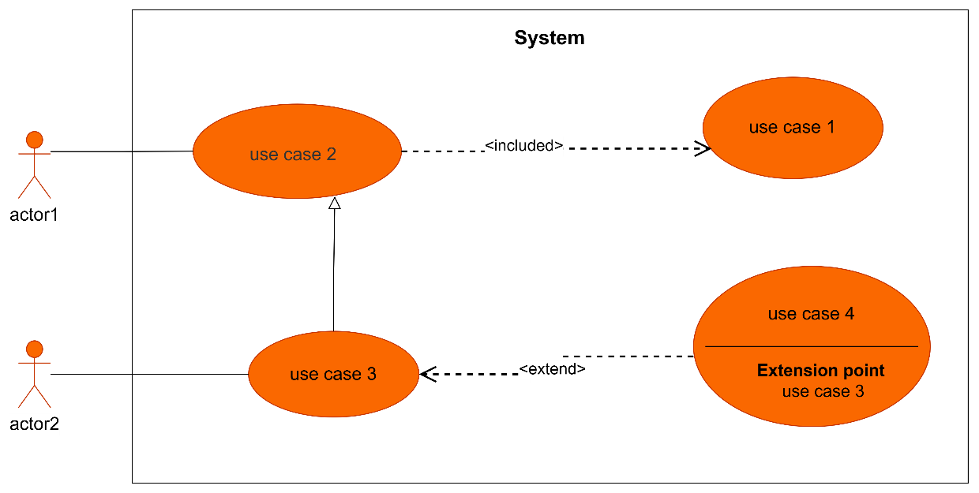
Figure 6: formalism of a use case diagram

3. The Component of the use case Diagram
Table 15: Components of use case diagram
Elements | Representation | Description
Actor | 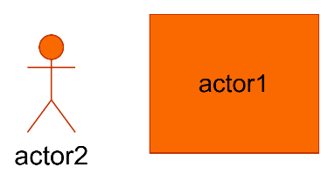 | Represents the entity who directly interacts with the system. The actor is one who performs the different tasks or actions of the system.
Use Case | 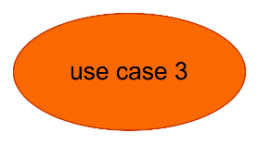 | it represents the functionality of the system. It is an action that an actor can perform
Generalization | 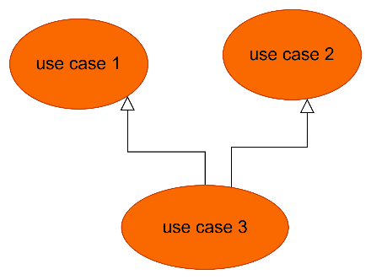 | Generalization is a relationship between a general use case (the parent) and a more specific use case (the child) that inherits and can add to or override the behavior of the parent use case.
Inheritance |  | this is the only possible relationship that can exist between actors whereby an actor can inherit from another
Include | 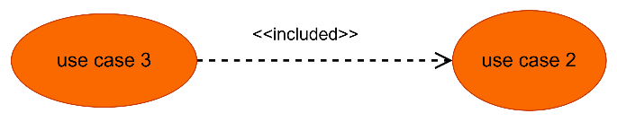 | It denotes that an included action must be performed before another action can be done.
Extend | 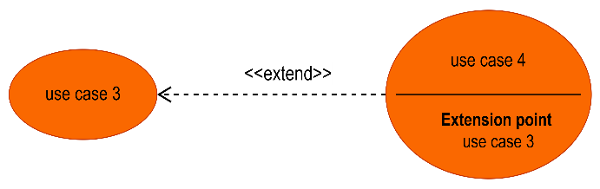 | It denotes that an action may be performed while another action is going on e.g. a use case B extends A implies B is an optional part of A
4. The Actors of our System
Table 16: Actors of our System
Actor | Role in the System
Visitor | An unregistered individual who can access the system to create an account
Citizen | Eyewitness or victim who authenticates, triggers SOS alerts, reports local incidents, consults detailed incident logs and confirm/contest nearby incidents.
Emergency Services | Authorized personnel who receive alerts, inspect alert evidence, update incident statuses to mark them as Resolved or False alert.
System Admin | Supreme gatekeeper auditing registrations, assigning custom service titles, toggling face unblur, executing overrides on AI results, managing user accounts, consulting alert evidence and viewing system analytics.
Gemini 3.5 Flash API | AI service analyzing audio, text, and photos to score citizen’s credibility during an incident report.
Twilio API | Communication gateway responsible for generating and sending SMS OTPs during the authentication process, and also executing automated bilingual voice calls and emergency SMS dispatches.
Firebase Cloud Messaging (FCM) | Notification service that dispatches priority local danger alerts to mobile terminals in affected zones.
Open Street Map | Mapping service providing the visual tiles required to render the spatial heat map.
SMTP Server | A standard mail server used for sending out email-based communications, such as feedback confirmations and other notifications.

General Use Case Diagram of SOS Report

Specific Use Case Diagrams
Specific, Use Case of Report Incident
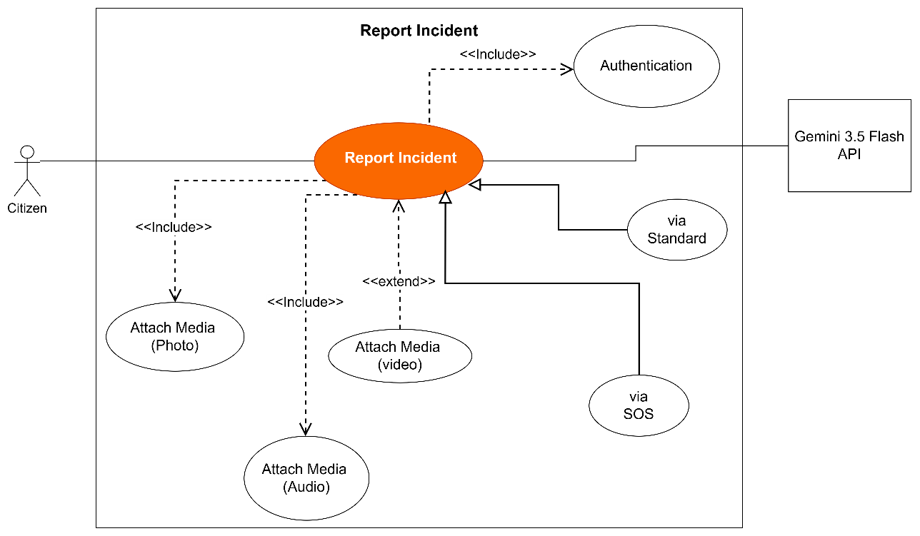
Figure 7: Specific Use Case of Report Incident

Specific, Use Case of Monitor Incident
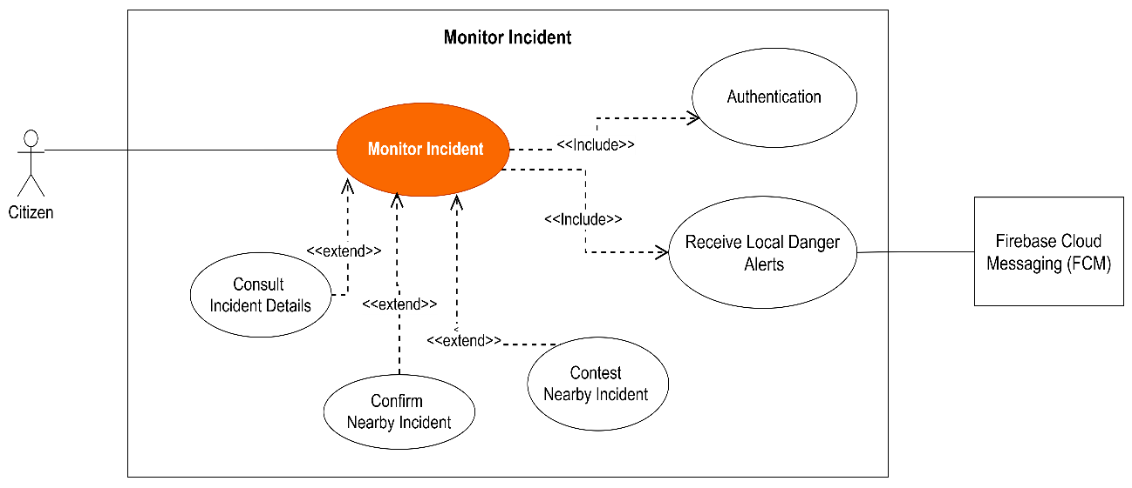
Figure 8: Specific Use Case of Monitor Incident

Specific, Use Case of Inspect Alert Evidence
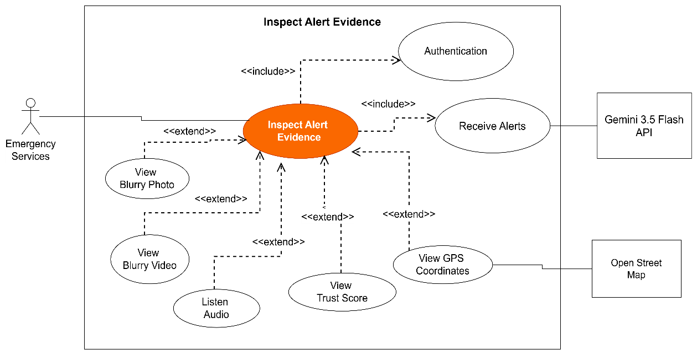
Figure 9: Specific Use Case of Inspect Alert Evidence

Specific, Use Case of Manage Users Account
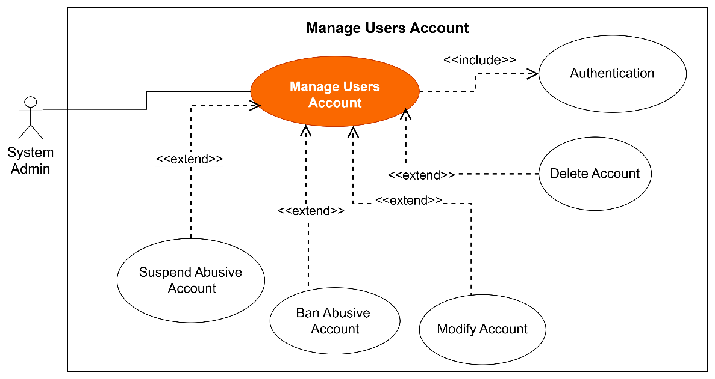
Figure 10: Specific Use Case of Manage Users Account

Textual Descriptions of Use Cases

B. Communication Diagram
1. Definition
The communication diagram is used to model the specific structural interactions between the participants of the system. It describes both the static and dynamic behavior of the system, showing the chronological succession of actions performed by an actor and how objects are linked to realize a specific operation.
2. Formalism

3. Components of the Communication Diagram
Table 17: Components of the Communication diagram
Elements | Representation | Description
Object |  | Represents a role or object instance that participated in the interaction model.
Message | 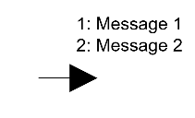 | Defines a particular communication between lifelines in an interaction.
Link | 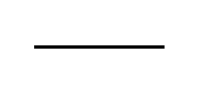 | It connects two objects together for them to communicate
Actor |  | It models the type of role played by an entity that interact with the subject

Communication Diagrams for SOS Report
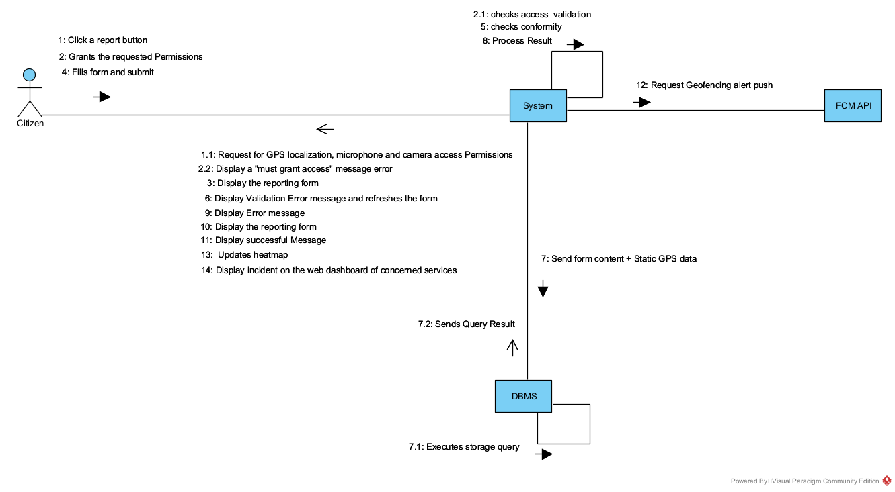
Communication Diagram of

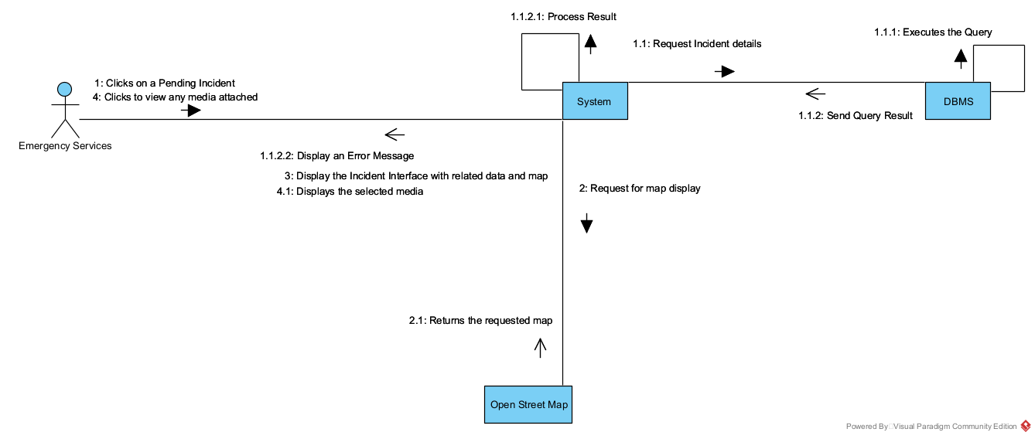
Communication Diagram of

Communication Diagram of
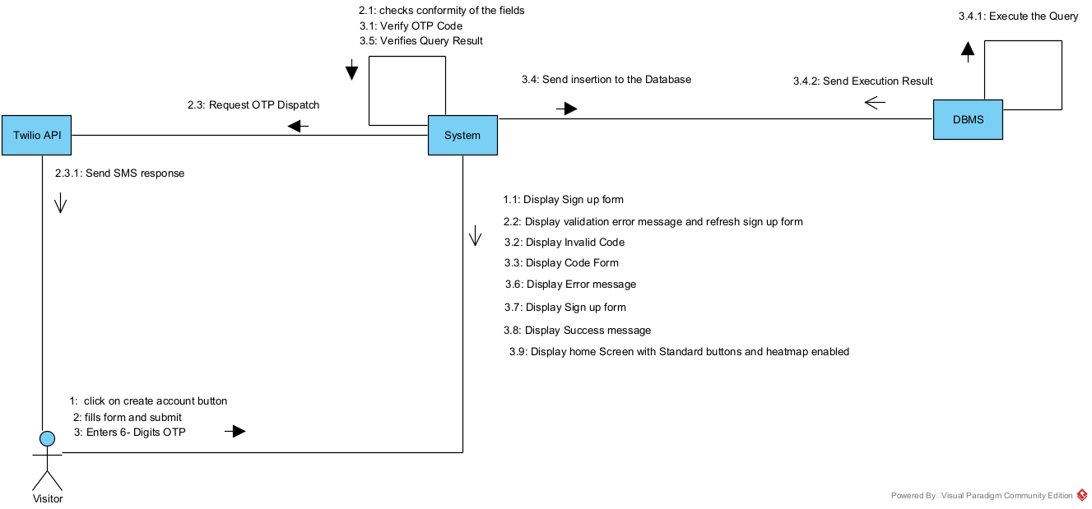

C. Sequence Diagram
1. Definition
A Sequence diagram is a UML behavioral diagram that illustrates the sequence of messages exchanged between objects over time. It is essential for visualizing runtime scenarios, validating how the system will behave chronologically, and discovering the specific responsibilities of classes.

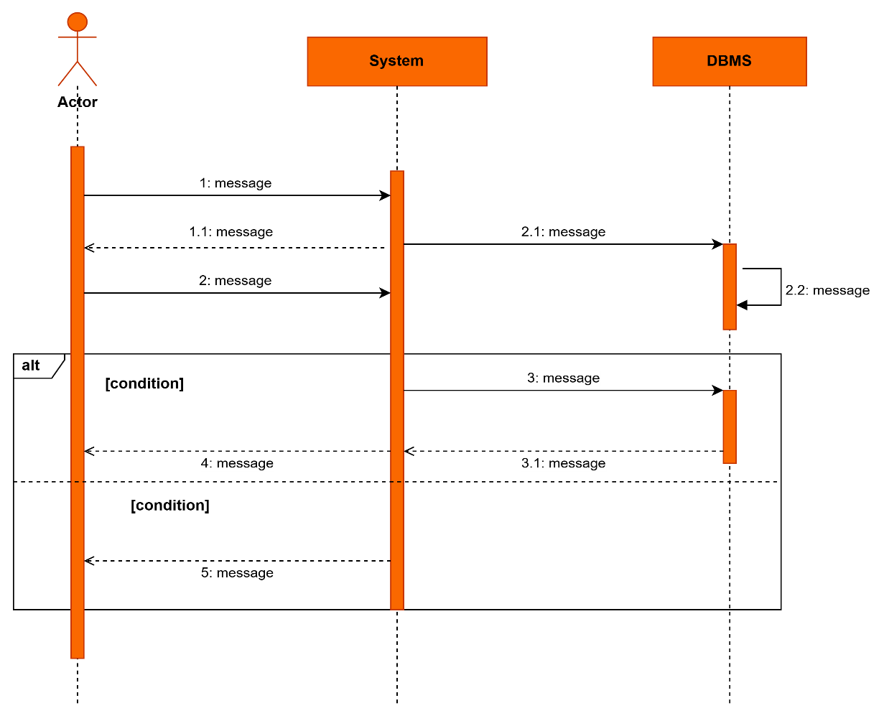
2. Formalism

3. Components of the Sequence Diagram

Elements | Representation | Description
Lifeline |  | They represent rows or object instances that participates in a sequence being modeled.
Asynchronous Message |  | It is a message that receives an indirect response
Synchronous Message |  | It is a message that sends and want response before it continues a process
Actor |  | They send and receive message.
Combined Fragment |  | It represents a choice of behavior in which at most one operand will be chosen.
Self-Message |  | Represents the execution or operation call on the same object
Return Message |  | Represents a response to a message

Sequence Diagrams for SOS Report

D. Activity Diagram
1. Definition
An activity diagram provides a visual view of the behavior of a system by describing the sequence of actions and decisions in a process. It formalizes the workflow of a use case, allowing us to map out parallel branches, conditions, and concurrent executions.
2. Formalism

3. Components of the Activity Diagram

Elements | Representation | Description
Lifeline |  | They represent rows or object instances that participates in a sequence being modeled.
Asynchronous Message |  | It is a message that receives an indirect response
Synchronous Message |  | It is a message that sends and want response before it continues a process
Actor |  | They send and receive message..
Combined Fragment |  | It represents a choice of behavior in which at most one operand will be chosen.
Self-Message |  | Represents the execution or operation call on the same object
Return Message |  | Represents a response to a message

Element | Description
Initial Node | A filled black circle marking the start of the workflow.
Action | A rounded rectangle representing a single step or operation.
Decision Node | A diamond shape indicating a conditional branch in the flow.
Activity Edge | A directed arrow connecting nodes and actions.
Final Node | A circle with a filled center indicating the termination of the workflow.
4. Activity Diagrams for SOS Report

CONCLUSION
The analysis file allowed us to rigorously delimit the functional needs of the SOS Report application. By utilizing UML diagrams within the 2TUP framework, we have secured a detailed, chronologically and structurally accurate overview of the new system before moving into technical implementation.

FILE 4:

CONCEPTION PHASE

Preamble

The Specification Book is a document created between the client and the developer to define what the product must do and how it should behave. It guides the development process by outlining all the required features, goals, and constraints. For this project, it serves as a reference for building an AI voice agent platform for interview preparation. Its purpose is to ensure that the final product meets user needs and follows clear, agreed-upon expectations throughout the development phase.
Content

INTRODUCTION

I.
CONTEXT AND JUSTIFICATION OF THE PROJECT

II.
OBJECTIVES OF THE PROJECT

III.
EXPRESSION OF NEEDS

IV.
PROJECT PLANNING

V.
ESTIMATED COST OF THE PROJECT

CONCLUSION
VI.
VII.
PROJECT CONSTRAINTS

DELIVERABLES

